**American International University-Bangladesh (AIUB)**

**Faculty of Engineering**

|  |  |  |  |  |  |
| --- | --- | --- | --- | --- | --- |
| **Course Name:** | COMPUTER AIDED DESIGN AND DRAFTING | | | **Course Code:** | BAE 2101 |
| **Semester:** | Fall 2020-2021 | **Assignment Name:** | **OBE Assignment (CO2 & CO4)** | | |
| **Submission Date:** | **29/04/2021** | | | | |

|  |  |  |  |  |
| --- | --- | --- | --- | --- |
| **Category** | **Excellent** | **Good** | **Acceptable** | **Secured Marks** |
| Civil Plan  [10] | The civil plan is unique and drawn as per requirements with proper dimensions.  [7-10] | The civil plan is drawn partially as per requirement with minor errors.  [4-6] | The civil is either copied or very poor with major errors.  [1-3] |  |
| Electric Fittings  [5] | The fittings are placed rationally and maintaining BNBC.  [4-5] | The fittings are placed rationally but not maintaining BNBC.  [2-3] | The fittings are placed randomly and not maintaining BNBC.  [1] |  |
| Conduit Layout  [5] | The conduit layout is done properly maintaining color code and standard connection practices.  [4-5] | The conduit layout is done maintaining color code but not maintaining standard connection practices.  [2-3] | The conduit layout is not done maintaining color code and standard connection practices.  [1] |  |
| Load Calculation  [5] | The load calculation is done correctly according to BNBC.  [4-5] | The load calculation is done according to BNBC but with minor errors.  [2-3] | The load calculation is done not according to BNBC with major errors.  [1] |  |
| Generator Capacity and Generator Room  [5] | The generator is chosen properly, and the generator room is designed according to BNBC.  [4-5] | The generator is chosen properly but the generator room is not designed according to BNBC.  [2-3] | The capacity of the generator chosen is wrong and also the generator room is not designed according to BNBC.  [1] |  |
| Total Marks:  (Out of 30 Marks) | | | |  |

**GROUP NO:**

|  |  |  |  |  |
| --- | --- | --- | --- | --- |
| **SL #** | **ID** | **Student Name** | **Class Serial No.** | **Department** |
| **1.** |  |  |  |  |
| **2.** |  |  |  |  |
| **3.** |  |  |  |  |
| **4.** |  |  |  |  |
| **5.** |  |  |  |  |

**Question #**

Let us assume, you have been working in a group for last two months with your friends. Now, you want to invest in a real-estate business. So as par plan, you have purchased a land of 1 Bigha at Bashundhara R/A, Dhaka where your group will construct a 11 Storied building (**Ground + 10 Floors**) of **having 6 units** – ***A, B, C, D, E & F*** in each floor. **You are asked to design for only “A unit” flat of having** **1600 sq-ft** (approx.) based on the following specifications:

* *3 Bedrooms:* ***[size: Bedroom-1 (Master Bedroom) is 17' x 14', Bedroom -2(Kid’s Bedroom) is 16' x 13' and Bedroom -3(Guest Bedroom) is 12' x 12']***
* *3 bathrooms:* ***[Size: Attached bath of Bed-1 & 2 is 8’x 8', bath of Drawing (Common Bath) is 7' x 7')***
* *Living/Drawing:* ***(Size: 17' x 14')***
* *Dining:* ***(Size: 15' x 15')***
* *Kitchen:* ***(Size: 12' x 10')***
* *3 Veranda:* ***(Size: 4' x 10' each)***
* *Storeroom:* ***(Size: 8’x8’)***
* *Door for kitchen / bathroom / veranda -* ***2'6'', Door for Bedroom - 3' and Main Door 4' (interior to interior)***

**Considering the abovementioned specifications do the following using AutoCAD 2007 Software:**

|  |  |
| --- | --- |
| 1. **Draw the** **Civil Plan (figure 1)** of the flatalong with **stair, lift** and **lobby (Space: 25*' x 20'****, which is excluded from the flat size***)**. **[*Hints: Brick to interior/exterior Offset distance = 10*'',* Stair Offset distance = 6*''*].** | **[10]** |
| 1. **Draw** the **proper Electric Fittings (applying BNBC) (figure 2)** | **[5]** |
| 1. **Draw** the **electric conduit layout (Wiring – applying BNBC) (figure 3)** where **Red, Green & Blue color** represents **light load, medium load & heavy load,** respectively. You must specify the names of light loads, medium loads and heavy loads beside your diagram, or you can attach the names of all the loads [specifying their type (light/medium/heavy)] in a different page | **[5]** |
| 1. **Calculate** the **load** for **one unit only**. Also **Calculate** the **load** for each **floor** and **load for the building** considering all the flat types are same and same types of load. | **[5]** |
| 1. **Calculate** the **capacity** of the **Generator** based on the load calculation. **Draw** a separate **Generator room** and **show** the connection with distribution board. | **[5]** |

**Note:**

* **Please mention your Names, IDs and Class serial number beside the figure that you will draw.**
* **Please submit “PDF FILE”**
* **Please save the file: “CAD_OBE_GROUP NUMBER”**
* **Please submit in Microsoft Teams Form**

**Remember, any indication of cheating will result in final grade ‘F’ regardless everything.**

Sample Drawing

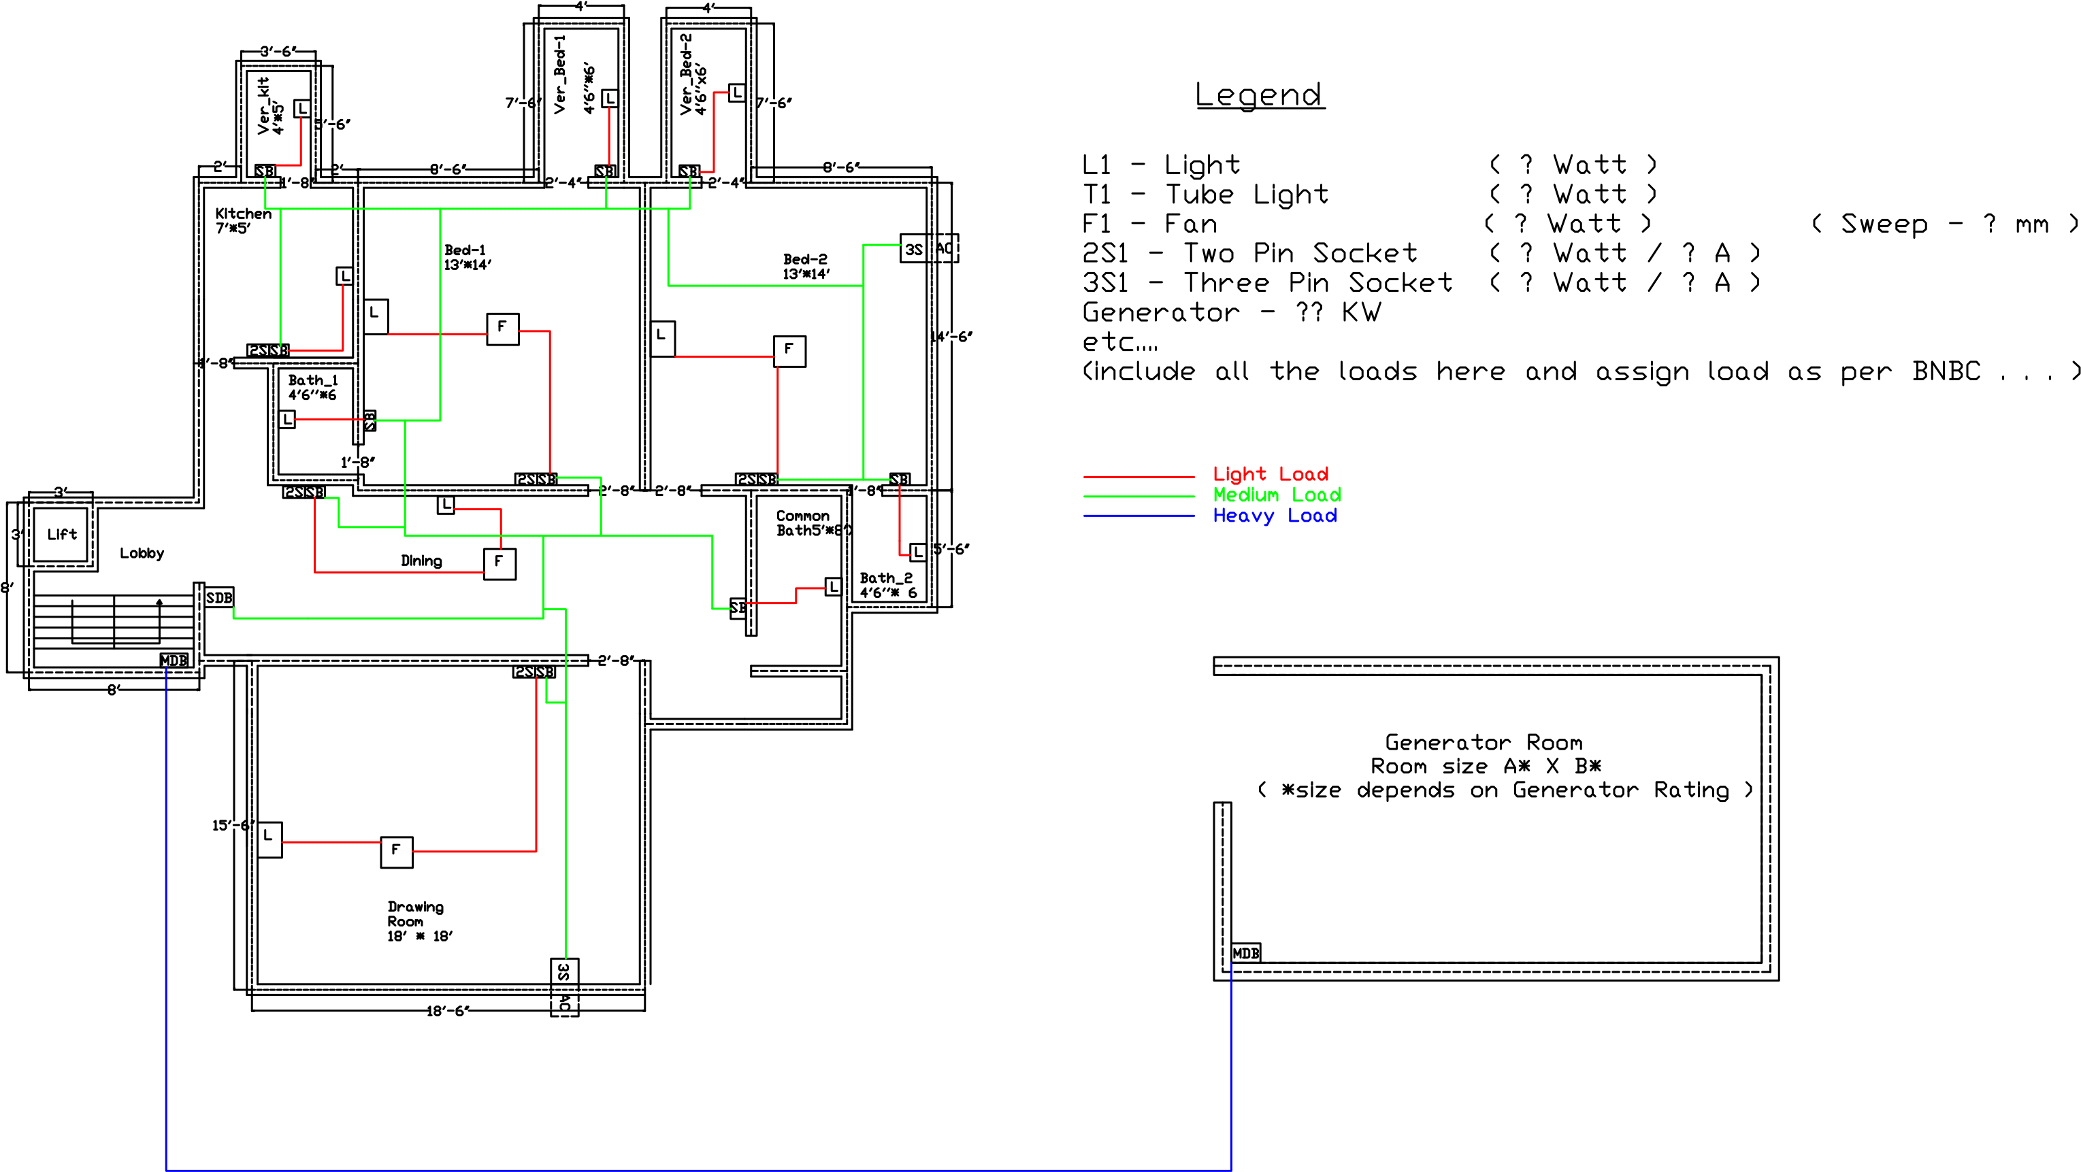

**Load Calculation:**

Suppose, there are total 5 lights of 40 Watt and 3 Fan of 80 Watt, so total load should be (5 x 40) + (3 x 80) or, 440 Watt. Similarly, include all the loads and calculate the **load** for **one unit**. Then, calculate the **load** for **a floor** just multiplying total loads of one unit with number of units in each floor and calculate **total load** for the **building** just multiplying the number of floors. On the ground floor comprises a small room (for MDB and water pump), garages and one small flat for security guard. So, calculate the load for the ground floor carefully.

*\*\*\* You can follow the attached sample but don’t think you need to design like this. You should use your imagination. Approximately 5 % deviation of total area in sft is acceptable.*